Volume of a hexahedron

It is assumed that a hexahedron is built of two quadrilaterals (top and bottom) whose coordinates projected on the x-y plane are equal (i.e. the top views show equal quadrilaterals). In that case, the volume of the hexahedron can be calculated by calculating the covered volume under each quadrilateral, subtracting these two values, and taking the absolute value.

A quadrilateral is defined as follows.
y
ξ
x
2
3
4
1
η

For such a quadrilateral it holds that

or
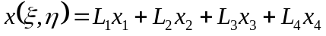
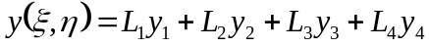

where
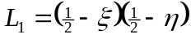
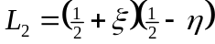
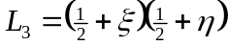
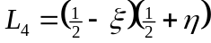

The covered volume under a quadrilateral is defined by the following integral.
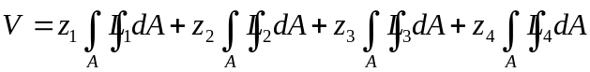
where
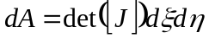

and
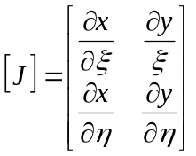

where
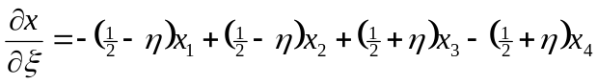
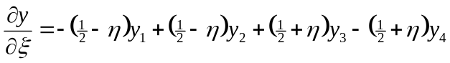
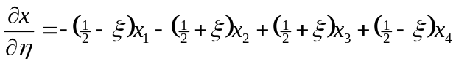
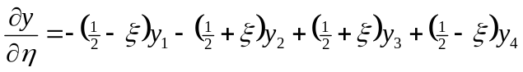

The integral
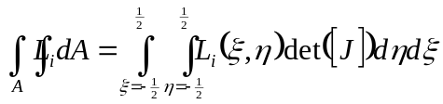

can be solved numerically
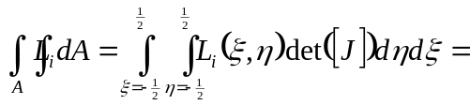
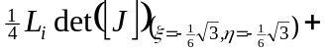
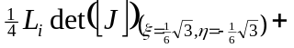
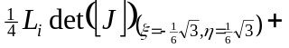
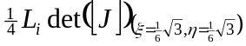

This is done for both the top and bottom quadrilateral. The two values are subtracted, and the absolute value of the result is returned as the hexahedron’s volume.

